eLumen Curriculum-Course Basics

Logging In

To log into eLumen, enter your college’s eLumen site address in your web browser:

- elac.elumenapp.com
- lacc.elumenapp.com
- lahc.elumenapp.com
- lamission.elumenapp.com
- pierce.elumenapp.com
- lasc.elumenapp.com
- lattc.elumenapp.com
- lavc.elumenapp.com
- wlac.elumenapp.com

You will be redirected to the LACCD Single-sign-on (SSO) login page. Enter your regular LACCD username (“Student ID, SAP ID or Office 365 Email”) and password. Once logged in via the SSO, you will be redirected back to the eLumen site.

General Curriculum-Course Navigation

Once logged in, you will see the following standard set of navigation banners and tabs (with your name in the upper left, of course):
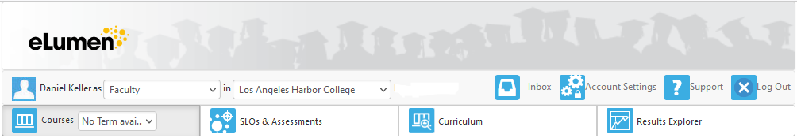

Your default role will appear next to your name. If you have more than one role, you may select another from the drop-down menu.
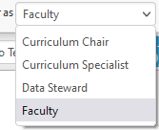

Your default “department” will appear next to your role. This indicates the organizational structure(s) in which you operate in your selected role. For example, if your role is “faculty,” the drop-down will list the departments/divisions/subjects in which you teach. Most faculty users will only see one. However, if you teach in more than one, you may select another from the drop-down menu. The following example is typical of a Curriculum Specialist, who would have access to all departments.
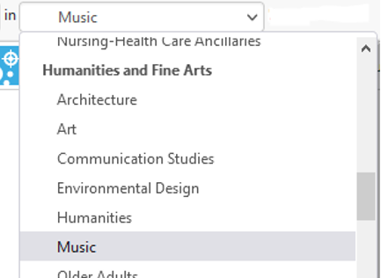

When the “Curriculum” tab is selected, the “Curriculum Dashboard” and “Course” screens are displayed by default. The dashboard shows all current workflows (proposals) in progress, grouped by workflow type (such as revisions, creations, etc.). The “Course” link shows course workflows in the dashboard, and the “Program” link shows program workflows. (This document will focus exclusively on the former.)
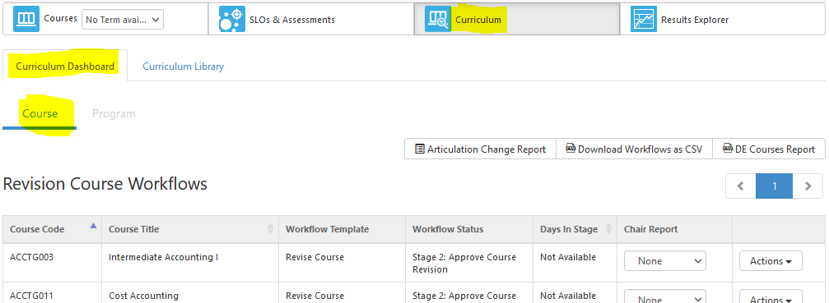

Links to various reports may appear above the list of workflows. (Typically, workflow authors will not need to view these reports.)

When the number of workflows exceeds the default display number, the navigation arrows can be used to navigate through multiple pages.
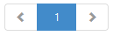

To the right of each course workflow, the “Actions” drop-down menu enables the following:
- “View” opens the workflow. If you are the author, you may continue to edit it.
- “Status” indicates where the workflow is in its approval routing.
- “View COR” displays the internal Course Outline of Record, showing every field available in the system (including those that do not pertain to the course in question).
- “Change Report” compares the workflow version to the active version (if applicable).
- “Impact Report” indicates the relationship between the course and any programs with which it is affiliated, as well as any other courses linked by requisite or advisory relationships.
- “Delete” deletes the workflow.
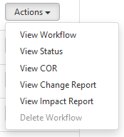

Another way to see in-progress workflows associated with you is to click the “Inbox” icon in the banner across the top of the page. The “Organizations” drop-down menu enables searching workflows by department/subject. The “Workflow Type” drop-down menu enables searching by type of workflow (revised, create, deactivate, etc.). Or you can enter key words in the “Search” bar. Note: The keyword search will search the course subject, number, and title for any instance of the key word. Thus, it is the least specific way of searching. To find a specific course, it is advisable to narrow the options in the “Organizations” drop-down menu, then add the number or other key word in the search bar, or just scroll down to the workflow you need.
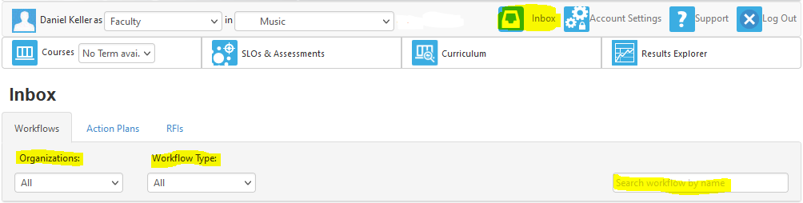

When the number of workflows exceeds the default display number, the page navigation buttons can be used to move between pages of workflows.
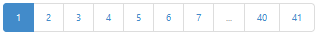

You may “Start” or “Continue” reviewing a workflow by choosing the desired option in the drop-down menu to the right of the entry.
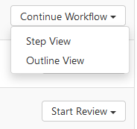

You may choose either “Step View” or “Outline View”. Step view divides workflows into multiple headings (or “steps”), displayed as separate tabs. Outline view combines the entire workflow into a single page with banners identifying each step heading. Note: Step view typically takes less time to load, but adds loading time each time you change tabs/steps. Outline view takes longer to load initially, and requires more scrolling, but does not require loading time between headings/steps.

Editing a Workflow

Workflows are divided into “Steps,” “Parts,” and “Fields.” “Steps” are main headings represented by a tab in “Step View” or a blue banner in “Outline View”. “Parts” are sub-headings contained within grey boxes under each step. “Fields” are data entry points within each part. When a step exceeds the height of the screen, grey scroll bars appear on the right.
Step
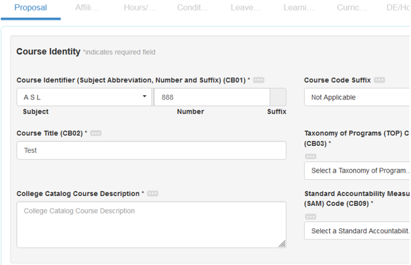
Field
Field
Field
Field
Field
Field
Field
Part

Depending on your role, the workflow type, and what has been previously entered in the workflow, some parts and fields or ineligible field options may be hidden.

Workflow Guide

A “Workflow Tools” banner appears near the top of each step. It is intended to help you choose eligible options for all required fields. It can be expanded or collapsed using the down/up arrow near its right side. When expanded, it shows the number of fields that require your attention, and then lists them under the “Workflow Guide” tab, separated into the following headings: “Required fields to Save as Draft,” “Required fields to Submit,” and “Internal Rules Validation.” For longer lists, a scroll bar appears on the right side.

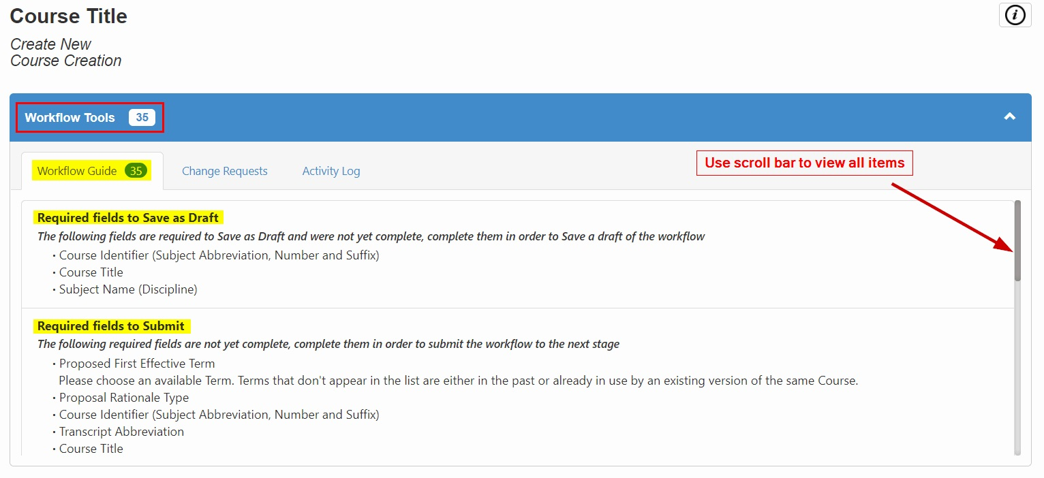

In order to save a workflow as a draft (so that you can continue editing it later) you must first define the course subject, number and suffix, title, and subject (aka department). To complete a workflow and submit it for review and approval, you must address all required fields.

Under the “Internal Rules Validation” heading, any field appearing in blue type is a hyperlink to the step and part where that field appears. Clicking it will navigate to the top of that part, then you can scroll down to the relevant field.
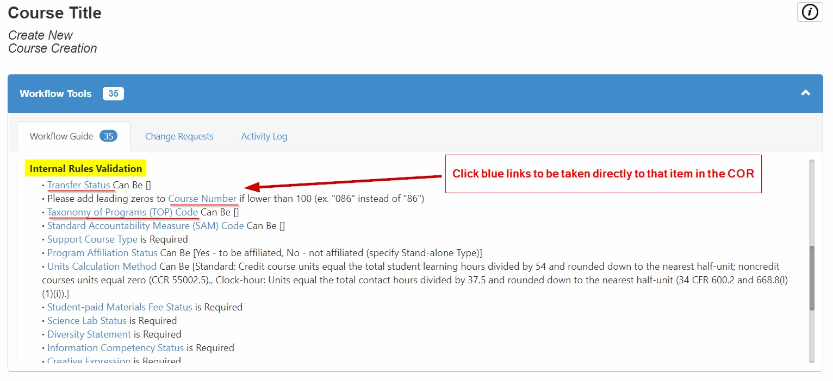

The “Internal Rules Validation” list contains fields whose eligible options are dependent on values entered in other fields. The rules that govern these dependencies are based on state regulations and/or district policies and procedures. (For example, entering a SAM code A, B, C, or D is only possible when the TOP code is vocational. Whereas, SAM code E is only possible when it is non-vocational.) Each item in the list provides a brief description of the relevant rule and/or displays the eligible options.

The “Activity Log” tab keeps track of all workflow user activity. Typically, workflow authors will not need to use this feature.

Workflow Navigation

When in “Step View,” a navigation banner lists each step as a hyperlink. The current step will appear in dark blue type, underlined in blue. Other available steps will appear in light grey type. Steps with longer titles appear truncated with an ellipsis (…). Depending on the magnification level of the screen and/or your scrolling activity, the step navigation banner may appear on the top or bottom of the page, or in the middle, underneath the Workflow Tools banner.

The following summarizes the steps and parts that may appear in a workflow.
- Proposal
  - Course Identity (subject, number, title, etc.)
  - Proposal Details (effective term, rationale, etc.)
  - District Schedule Description (the more generic district-wide description developed by the Discipline Committee)
  - Minimum Qualifications (auto-filled, based on Academic Senate-approved discipline to subject mapping)
- Affiliations
  - Program Affiliations
  - Transferability, General Education, Articulation, and Cross-listing
  - Function (program/stand-alone status, basic skills status, credit status, etc.)
- Hours/Units
  - Contact Hours per Week
  - Weekly Specialty Hours (LACCD does not use this part)
  - Hours and Units per Term calculations
  - Unit Calculation Method (standard, cooperative education, clock hours)
  - To Be Arranged status
- Conditions on Enrollment
  - Requisites and Advisories
  - Content Review
  - Non-course Conditions
  - Validation
  - Student Fees
- Leave Blank: This step is not used in the LACCD.

- Learning Outcomes
  - Objectives
  - Learning Outcomes
  - Content (lecture/lab and other factors)
  - Textbooks/Content Resources
  - Library/Learning Center Resources
  - Methods of Instruction
  - Assignments
  - Evaluation and Grading
  - Credit for Prior Learning
  - Active Participatory Status and Repeatability (for performing arts, etc.)
  - Feasibility (resources plan for new courses)
- Curriculum Mapping
  - This step enables you to map course learning outcomes to program, general education, and/or institutional learning outcomes or other standards.
- DE/Honors
  - Distance Education (status, regular effective contact methods, etc.)
  - Honors (status, objectives, activities, etc.)
  - Curriculum Technician (C-ID/honors status, requisite validation, etc.)
  - Financial aid status
- Curriculum Technician (not editable by the workflow author)
  - Other codes and dates
  - Other articulation fields

Fields may consist of text boxes (some enabling word processing features), drop-down selection menus, check boxes, redial buttons, numeric entry boxes (with increase/decrease arrows), date entry boxes (with pop-up calendars), and upload file buttons.

Most fields have an ellipsis icon (three dots: ) to their right. Clicking on this will open a help text or prompt with information about what should be entered.

In general, if a field is not required and not applicable, leave it blank. Please do not enter “Not applicable,” “N/A,” or any similar text into any field unless the workflow cannot be submitted without it. The same is true for numerical fields: there is no need to enter zeros (“0”).

At the bottom of each step there is a “comments” field where you may leave comments, notes, or questions for other reviewers. Anything entered in this area is visible to all users at every step in the workflow prior to approval. Comments also list their author and date, and cannot be deleted or edited. However, comments do not appear in the public course outline of record.

Action Buttons

At the bottom of each step, you will see the following action buttons. Until all the required fields are entered, the “Save as Draft” and “Submit” buttons will be deactivated and will appear slightly greyed out.
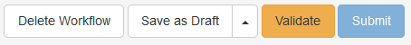
- “Delete Workflow” permanently deletes the workflow without submitting it.
- “Save as Draft” saves the workflow so that you can return to it later. (This can only be used when the minimum required fields are entered.)
- “Validate” reruns all rules validations. (Since rules are continually validated, this action is not necessary.)
- “Submit” submits the workflow for review and approval.
  - Clicking this button will bring up a confirmation window with Cancel/Submit actions.
  - After submitting, a “Finish” button will appear to allow you to finalize the submission.

After Submission

Once a workflow is submitted, it enters the college review sequence. Various reviewers/approvers will have the opportunity to review the workflow. Some will have the ability to send it forward or backward in the sequence.

Once the college approval sequence is completed, the workflow is transmitted to the district eLumen instance (laccd.elumenapp.com). If district-wide vetting is required (for example for proposed changes to shared district fields) it will enter the “Sunlight” dashboard. During “sunlight,” any Curriculum Committee Chair may “flag” the workflow for DCC review (aka, “challenge” the proposal). The DCC will then review the workflow and either send it forward to the district “library” of courses that have completed the review process, or send it back with comments. If send back with a request for changes, you may edit the workflow as before, and then resubmit it. If resubmitted, it will enter your college’s “send back” workflow sequence. Once complete, if the DCC Chair determines that the changes were made per DCC specification, the chair will send the course forward to the library.

Courses sent to the library will be entered into the student information system (SIS). Those requiring Board approval and State Chancellor’s Office Curriculum Inventory (COCI) approval will not be schedulable until those processes are completed. A college designee will then use an “Amend” workflow to add the required documentation.

Note: If any articulation element was requested (transferability, general education, C-ID, articulation in the major, etc.), the Articulation Officer will submit them to the relevant institution. Once the result is received, the AO will initiate an “Articulate” workflow and update the status of the request accordingly.

Both “Amend” and “Articulate” workflows will update the original workflow with the new information.

